Case study 1: Rabies
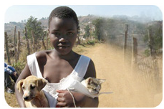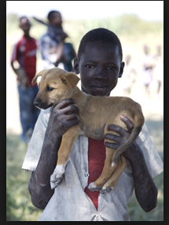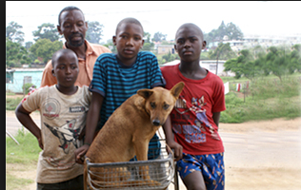
Batamuliza, a 10 year old girl, the daughter of Mr. and Mrs. Basaza, a resident of Nyagatare, Rwanda traveled to Uganda to visit her grandmother and spent there 1 week. While she was away, she was bitten by a stray dog. When she returned home, she was not feeling well and the dog wounds were getting infected. She told her mother what had happened and her mother found some traditional herbs and gave them to her. When she did not get better the mother brought her to the traditional medicine man, who cast out the evil spirits that he said were bothering the girl. After a few days the mother realized that Batamuliza was getting worse and brought her to the local health center. At the health center, the nurse realized immediately that the dog might have been rabid. She gave the girl a rabies post exposure vaccine. She also quickly called the veterinarian in charge who called his counterpart in Uganda to ensure that the dog was captured and did not bite any more people. They found out that the dog had also bitten two other children in that village and several cows which had developed rabies. On further investigation, the veterinarian discovered that the dog had been infected by some wild fox which liked to come and scavenge for food in the village. The women in the village liked to feed the fox because they believed in the tradition that if you fed foxes, you would be more fertile. The veterinarian called a meeting of the village elders and did a brief community training on rabies. Batamuliza got better after a few days and went out to play with her friends.
Question
- Who are the people affected in this case?
- Can you list the different sectors that you can identify who could work together well/ what other sectors would you have liked to involve?
- What would you have done differently?
- What can you do to prevent the situation from getting to this stage?
- Do you support everything that the veterinarian did: why/why not?
- If you were a district veterinary officer, how would you manage this problem in your community?
- What gender issues do you see in this scenario and how would you deal with them?

Case Study 2: Bovine Tuberculosis
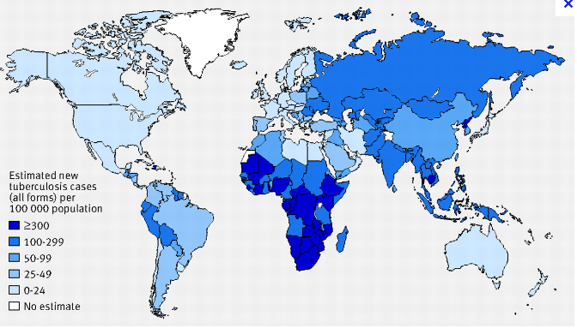
Every year, there are 8–10 million new cases of TB reported, and 2–3 million deaths attributed to TB. In many countries in Africa, HIV-AIDS is widespread. The biggest killer of people with HIV-AIDS is tuberculosis. However, the Impact of Bovine TB on humans is poorly documented. BTB is a major problem for livestock in developing countries and wildlife play a major role in the failure of TB eradication programmes. In many cases, Consumption of raw meat and milk and development of bush meat consumption as cheap source of protein are the principal routes of human contamination with BTB. Human tuberculosis (TB) of animal origin (zoonotic TB) is an important public health concern in developing countries. African nations face a particular challenge in TB control, deficiencies in public health control measures for cattle and animal products. Once detected, tuberculosis is curable in 90 percent of cases for as little as $15 per treatment
HIV/AIDS is fueling the TB epidemic, and coordination between the TB and HIV communities is lacking. The spread of extensively drug-resistant TB (XDR-TB) is a major threat and there is a significant lack of infrastructure and capacity, including laboratory facilities and health workers. This is made worse by the fact that smaller, less-regulated farmers sell unpasteurized milk directly to consumers and most consumers in the village do not boil their milk to the required standards. Mycobacterium bovis has a broad host range as the principal cause of TB in free-living wildlife, captive wildlife, domestic livestock, and non-human primates. Wild ruminants and carnivores, such as African buffalo, lion, cheetah, greater kudu, leopard, warthog, and eland, can be infected and infect both humans and domestic animals. Scavengers (hyenas, genet) and Chacma baboons in Kenya became infected through the ingestion of abattoir wastes. Furthermore recent development of wildlife activities, such as game tourism, farming, and hunting to develop the peripheral zones of protected areas has increased human contact with wild animals. Due to international travel and migration, TB is now considered a rapidly re-emerging pandemic. Many cases diagnosed are Multi- drug resistant (MDR) or XDR.
Given this scenario
- Who and what are the different stakeholders in the case of Tuberculosis?
- What disciplines should work together to control this re-emerging pandemic?
- What are the benefits of cross sectoral cooperation and the sharing of resources
- What gender issues do you see in this scenario and how would you deal with them?
- How can you begin to address some of these issues
- Can you lay out a strategy on how you would go about controlling the spread of Tb in your community?
- What are the benefits of cross-sectoral cooperation and the sharing of resource and information between countries?

Case Study 3: Environmental, wildlife and health issues in Kilosa District Tanzania
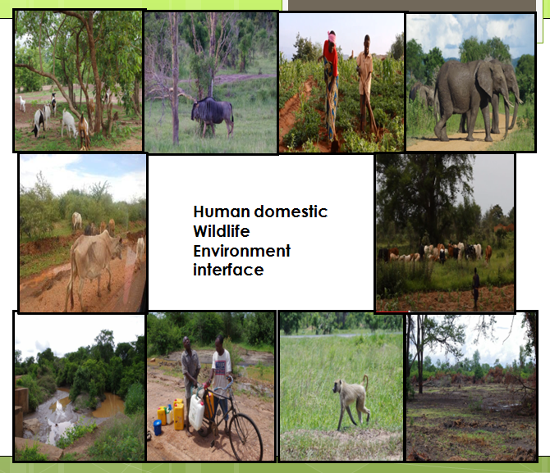
In light of the increasing global demographics, disease emergence and intensified encroachment on natural habitats, meeting the needs of the community and safeguarding their health is becoming a significant challenge. Engaging communities in one health activities is one way to ensure that they are involved in the planning, implementation and management of activities and interventions right from the beginning. In Kilosa district of Tanzania, close to the Mikumi national park, Wildlife, livestock and people live in close proximity making the plains a potential “Hot spot” for emerging pandemic threats. This area has been identified as ideal for a one health demonstration site. Specific human health, animal health, and ecosystem challenges and impacts were identified, such as local human, livestock and wildlife diseases, habitat fragmentation, edge effect and biodiversity loss. The Kilosa region was found to be strategically positioned in terms of cultural resources and vulnerable populations as well as endemic or threatened wildlife species. Rabies, Rift Valley Fever and milk borne (Bovine Tuberculosis and Brucellosis) as well as water borne zoonoses were identified by community members as priority diseases that would be intervened effectively using one health approach. There was ongoing conflict among pastoralists and farmers, and the national parks administration. Wildlife like elephants constantly destroyed farmers’ crops and human wildlife conflict was rampant. Environmental degradation was evident with community members cutting down trees to sell charcoal. Recent flooding in the area had led to massive soil erosion as well as people and animal displacement. As a result of this, there was conflict over scarcity of water resources for wildlife, animals and humans. Poaching in the Mikumi national park was constant and road kill of wildlife was big problem since this was the main high way for transnational tracks from Tanzania to southern Africa. Conflict between the national park rangers and communities also resulted from the fact that women went into the park to gather firewood and fruits for food. Potential opportunities for the demonstration site to contribute to the local economy by virtue of employment, improved subsistence resources, conservation and sustainability, biodiversity protection, improved recreation or appreciation by tourists were present.
Questions and facilitator notes
- Why do you think it is ideal for one health activities
2. Identify key issues that are problems in this area?
3. Identify key stakeholders in the area?
4. What one health related interventions can be done and how can you engage key stakeholders in the interventions?
5. What gender issues do you see in this scenario and how would you begin to deal with them?

Case study 4: Mining in Lake Tshangalele: Environmental and health impact assessment in the Democratic Republic of Congo
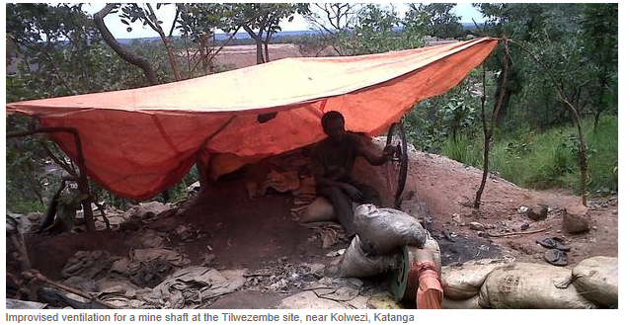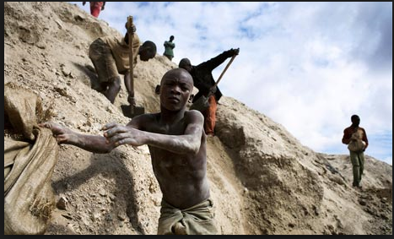
http://www.amnesty.org/en/news/chinese-mining-industry-contributes-abuses-democratic-republic-congo-2013-06-19
To provide incentives and attract investors to the mining sector a new mining code was enacted in the DRC in July of 2002. The new code attracted several new mining companies generally of smaller size compared to those operating at the time of the reform. For economic reasons, small mining operations tend to operate closer to large populations creating health and environmental problems. To mitigate the environmental impact of extractive industries, the government of DRC has recently enacted an environment framework law. However, this 2011 legislation still needs other implementation measures to guarantee its effectiveness.
The increase in mining operations in Lubumbashi, a city of 1.3 million inhabitants and surrounding areas has led to air and water pollution directly affecting humans, animals and the food chain. The mines are estimated to provide direct employment to between 200,000 and 280,000 permanent full-time miners and are located only 0.1 km from the edge of the city (see Figure). During the peak season, the total number of miners reaches an estimated 400,000 workers. About 74% of miners are diggers while the remaining are sorters and washers.
Miners and their families are exposed to heavy metals through dust inhalation, food and water contamination. In Shinkolobwe and Kolwezi, miners are exposed to radiation of up to 24 mSv/year. Poor sanitary conditions in miners’ camps also favor epidemics. Recent studies have shown a significant risk of heavy metal contamination in humans, goats and fishes. Massive excavations related to copper mining operations affect the ecosystem such that the natural habitat of rodents and other animal carriers of pathogens that may cause known and unknown diseases are invading human habitats creating a serious health risk. In 2011, an outbreak of unknown disease with hemorrhagic fever like symptoms caused several deaths and hospitalizations in Kapolowe health district 114 Km North West of Lubumbashi. However, follow up was not made as there was generally a poor understanding of these exposures and their specific effects and they did not have adequate capacities to study and mitigate these problems. Evidence suggests fish from Lake Tshanga-Lele located in the same district are heavily contaminated. Fish from this lake constitute a main source of protein for the population of the city of Lubumbashi. Illnesses of unknown origin have also been observed in goats within the same area. These kinds of exposures from mining and activities related to it may be associated with significant disease burden. The World Health Organization (WHO) estimates that environmental risk factors contribute to 24% of the global burden of disease from all causes, and to 23% of deaths, emphasizing that this is likely a conservative estimate because for many diseases, the associations are poorly understood (Prüss-Üstün and Corvalán, 2006).

Questions
- Given this scenario, what are the one health issues that arise and who are affected?
- Identify the multiple stakeholders or players in this scenario
- Can you suggest an intervention strategy for this community?
- Who would be your key players in the intervention strategy?
- What gender issues do you see in this scenario and how would you begin to address them?

Chart of Case studies and Roles

Case 1 | Case 2 | Case 3 | Case 4
Mother | Mother | Pastoralist(herder) | miner
Child | veterinarian | farmer | wife
Nurse | Medical doctor | woman | child
veterinarian | farmer | Park ranger | Chinese owner of mine
Village elder | Business Man | Tourist | Government official
Women group leader | Hunter | Government official | Fish monger
Traditional healer | Tourist | Village elder | herder
Government official | Government official | environmentalist | Medical doctor/public health
Public health person | Wildlife specialist | poacher | veterinarian
Dog owner | Milk consumer | veterinarian | environmentalist
 |  | Disaster manager | businessman

Advocacy videos:
There are three rabies advocacy videos
http://www.oie.int/en/animal-health-in-the-world/rabies-portal/
Her Royal Highness Princess Haya with OIE against rabies
No more deaths from rabies
Fighting rabies in Asia
There is a power point prepared by me on Gender advocacy- sent in as a power point- I will use it during the training. However, I do not want it changed or branded with OHCEA logo because it is my own preparation and I do not want it to belong to OHCEA.

